

Software Engineering Department  
 Braude College

Capstone Project Phase B – 61999

**Evaluating Thresholds for Errors Detection and Correction by Using a Game Task**

**Project ID: 23-2-R3**

Supervisor: Dr. Anat Dahan

Tal Cohen, [tal.cohen@e.braude.ac.il](mailto:tal.cohen@e.braude.ac.il)

Koral Ben David Jacob, [koral.ben.david.jaco@e.braude.ac.il](mailto:koral.ben.david.jaco@e.braude.ac.il)

**Table of Contents**

Abstract…………………………………………. 3

1. Introduction……………………………… 3

2. Background and Definitions 4

**2.1 Post-Error Slowing** 4

**2.2 Error Detection** 4

**2.3 ADHD and Error Detection** 4

**2.3.1 Brain Activity and Cognitive Error Monitoring** 5

**2.4 Kinematic Movement Measurement and Metrics** 6

3. Research / Engineering Process 8

**3.2 User Audience** 8

**3.3 Testing** 8

**3.4 Challenges** 8

4. Product……………………………………. 10

**4.1 Log Files** 12

**4.1.1 User Input Data Log** 12

**4.1.2 Error Sizes Log** 13

**4.1.3 Insights Log** 14

**4.2 Artificial Errors** 14

**4.2.1 Artificial Error Generation** 16

**4.2.2 Artificial Error Response - Detection and Correction**………………………………………………………...18

**4.2.3 Post-Error Slowing Assessment** 18

**4.3 Kinematic Data** 21

5. Results………………………………………. 21

6. Conclusions………………………………. 26

REFERENCES……………………………….. 27

# Abstract

The ability to monitor and adjust our performance is crucial for adaptive behavior, a key component of human cognitive control.

The primary objective of our research project is to study the different thresholds of error detection and correction for healthy (without ADHD) participants in our research and then check if individuals with ADHD exhibit different thresholds. In addition, we want to solidify post-error slowing phenomenon which may occur after an error.

We developed an interactive game using the Unity engine to test the error thresholds of the players.

The game presents users with the interactive task of steering a vehicle across a track. Artificial errors designed to gauge the detection threshold of players are induced and scattered pseudo-randomly as users engage in the task. We gather kinematic data for analysis and by analyzing the collected data, we measure the error detection and correction exhibited by players for different error sizes ranging from subtle errors to very noticeable errors, intending to quantify error thresholds (the error size at which the user recognizes an error).

# 1. Introduction

Monitoring and adjusting our performance are crucial for adaptive behavior. It is a key component of human cognitive control. For us to correct our errors they must be identified. One of the studied metrics in literature is post-error slowing (PES), the finding that humans tend to slow down their performance after making an error.

Motor errors can stem from a variety of factors, such as a lack of motor planning, and coordination, deficiencies in sensory feedback, wrong timing, and mistakes in judging spatial distances.

ADHD is a common disorder, and those who suffer from it, present one or more of the following symptoms: inattention, hyperactivity, and impulsivity. Studies showed that there is a direct link between ADHD and error detection monitoring and that ADHD limits the ability to detect, monitor, and correct errors.

Our motivation is to study the different thresholds of error detection for healthy participants in our research and then check if individuals with ADHD exhibit different thresholds. Our focus will be on Motoric and Kinematic errors. By researching this, finding a strong connection may even allow for developing a tool that will help diagnose ADHD over time.

In phase B, we developed a game (using Unity Engine) that tracks the player's motor movements as he controls the vehicle throughout the game. While playing the game, our system induces artificial errors as the vehicle passes underneath bridges and tracks the player's behavior and input following these errors. Some of the data we collect persists in the player's movement, position, velocity, acceleration, buttons pressed, etc.

By analyzing this data, we can gain new insights about people's error detection thresholds, post-error slowing, and its connection to ADHD.

The rest of the document will present a more in-depth view of the tool development process in terms of architecture, engineering problems, technical problems, and research results.

# 2. Background and Definitions

## **2.1 Post-Error Slowing**

Post-error slowing is a cognitive phenomenon where individuals tend to exhibit slower response times and more careful behavior and actions following an error or mistake on a task. It is a measure of how the brain and cognitive systems respond to errors and adjust our behavior accordingly to reduce the probability of performing such errors or mistakes again [1]

## **2.2 Error Detection**

Error detection monitoring in humans refers to the cognitive process by which individuals can identify and detect errors or mistakes in their actions, or behavior. It involves the ability to self-monitor and recognize when something is incorrect, inaccurate, or inconsistent with one's intentions or goals. It can occur in various cognitive domains, including perception, memory, language, decision-making, and motor skills [2].

Detecting and monitoring our mistakes is an important cognitive process that allows humans to correct errors, learn from mistakes, and improve their performance and accuracy over time. It is a fundamental aspect of human cognition and plays a critical role in tasks that require accuracy, precision, and goal-directed behavior, such as problem-solving, decision-making, and skilled performance [2].

## **2.3 ADHD and Error Detection**

Attention Deficit Hyperactivity Disorder (ADHD) is a common mental disorder that interferes with day-to-day activities. It is usually first diagnosed in childhood but also adulthood. ADHD symptoms include inattention, hyperactivity, and impulsivity. These symptoms can change over time as a person ages.

Studies among children and adults showed that people with ADHD have a limitation in their ability to detect and monitor errors. In addition, they are limited in their ability to slow down if needed to reduce the number of errors that occur or adapt to said errors [6,7].

### **2.3.1 Brain Activity and Cognitive Error Monitoring**

Studies have shown that while making a mistake or an error, certain regions in the brain respond to those mistakes and affect the cognitive actions afterward.

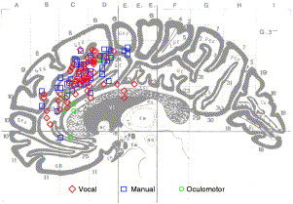

Figure 1: Region activation from imaging studies involving conflicts. Color coding refers to the model of response in the monitoring task (red-vocal, blue-manual, green-oculomotor) *[**2**]*

#### **Cognitive and Motor Errors**

Cognitive and motor errors are mistakes or inaccuracies that occur in cognitive and comprehension processes and motor actions. These errors may occur due to various factors. Some common errors are:

***Cognitive Errors:***

* *Perceptual and Contextual Errors:* Occur when the brain distorts sensory information. E.g., mistaking an object to be a different one or misperceiving sizes or shapes.
* *Attentional Errors:* This may happen when there is a lapse and/or lack of attention, or even over-attention while performing tasks [10].

***Motor Errors:***

* *Execution Errors:* Occur during the execution of motor actions. These errors may involve inaccurate movement, lack of coordination, timing issues, and unsubtle or sudden motoric actions.
* *Planning and Decision-Making Errors:* These errors happen due to deficiencies in the formulation or organization process of motor actions. Such errors may lead to inefficiency in performing simple or complicated tasks [10], difficulty with sequencing and prioritizing motor actions, and more.

## **2.4 Kinematic Movement Measurement and Metrics**

The ability to quantitatively measure human movement is important for understanding the kinematics involved in such movement [13].

Focusing on the upper extremity movements, clinical scale classifications have classified these movements into two main categories, functional movements, and activities of daily living (ADL) [14].

Movement-related metrics and profiles [14,15] (kinematic metrics) were proposed and studied before. Each metric is used to examine specific aspects of the motor or movement characteristics and to quantify kinematic movement [14].

#### **Movement Speed**

* *Movement time* – a measure of the time required to finish a functional task successfully. This measurement can also be calculated in phases/segments in the tasks [14]. (e.g., 1. Reaching for the object, 2. Stabilizing the object in the hand.)
* *Maximum and Mean velocity* – measurements of the velocity of the arm/object moved by the subject [14]. One aspect of measurement showcased that people with dysfunctions in motor movement or disorders such as ADHD have several peaks and noises [Fig 5] in their hand velocity profiles [14,15].



Figure 2:" An example of the differences of velocity profiles of a reaching movement for subjects with (left graph) and without ADHD (right graph). *" [**15**]*

#### **Movement Accuracy**

* *Movement deviation* – a measure of movement quality. The quality is calculated in terms of the deviation presented by the subjects from a desired trajectory. The deviation metric is "considered a measure of the error in accuracy" [14].
* *Target error* – measures the movement quality in terms of accuracy regarding the endpoint error (as mentioned in the literature). Endpoint error is the error calculated around the distance of the target placement from the user placement at the end of the movement [14].
* *Spatial overshoot* – is "a measure of the spatial excess in any direction of the movement" [14]. We consider it to be the spatial excess outside the limits and boundaries we described.

#### **Movement Smoothness**

* *Ratio between mean (average) and maximum velocity* – this ratio measures the quality of movement in terms of its smoothness. Subjects with movement disorders may present alterations during their movement patterns with relation to acceleration and deceleration, sharp and/or brisk movements. This metric could detect such alterations in movement [14,15].
* *Number of velocity peaks* – it is computed from the speed profile of the movement that was presented by the subject. Subjects with normal reaching movements will present only one velocity peak while with the presence of movement disorders smoothness of the motion deteriorates [Fig 2], resulting in more velocity peaks [14,15].
* *Mean arrest period ratio* – this metric is related to the number of unnecessary stops done in the time frame of the movement performed toward an objective. When such movement is performed several stops usually occur in its timeframe. People with movement disorders present a greater number of stops which causes the movement to be less smooth. "This metric has been computed as the ratio between the movement time in which the hand stops and the total movement time. The hand was considered “stopped” if the hand velocity was less than 20% of the mean velocity during the movement analyzed." [14]
* *Jerk* – the rate of change in a subject's acceleration profile during movement is represented by the Jerk metric. This measure is computed from the 3rd time derivative of the position vector during the hand movement, or, as the 2nd time derivative of the velocity vector of said movement. This metric measures the non-smoothness quality in the movement [14,15].

# 3. Research / Engineering Process

At first, we researched and studied the phenomenon known as Post Error Slowing (PES), reading various studies and research papers to understand its definition, diagnostic criteria, and implications. This research laid the groundwork for our next focus, attention deficit hyperactivity disorder (ADHD), alongside the study of various kinematic and motor errors and the methodologies for their assessment.

Motivated by our findings and guided by our supervisor and mentor, Anat Dahan, we decided on a research initiative aimed at developing a specialized tool for data collection and analysis. This tool was designed to gain new insights on critical questions surrounding the PES phenomenon and its connection to ADHD. Specifically, we aimed to determine the error detection threshold (how “noticeable” an error is) at which PES is triggered, investigate whether this mechanism operates differently in individuals diagnosed with ADHD, and is this “detection threshold” varies between people with and without ADHD. Intrigued by these questions, we began the development of our research tool. A tool that will collect data when players interact with it and while doing so, we shall create various artificial errors that will allow us to analyze the reaction and behavior of the users after encountering the errors.

## **3.2 User Audience**

The audience of the system includes researchers and clinicians interested in post-error slowing [paragraph 2.1] and its implications on error detection [paragraph 2.2], attention, and management processes specifically in motor actions [paragraph 2.3].

Overall, we believe that the system may serve as a versatile tool for assessing motor and attention processes, with implications for both research and practical applications in the field of ADHD research.

## **3.3 Testing**

First, we tested our software and functionality of the game using unit testing, play testing performed by us, and unity’s special debugging tools. For e.g., we tested the colliders blocking the car from exiting the track, and the event dispatching mechanisms.

We conducted our testing to understand what major functionality and gameplay we need to adjust or change entirely in the game. Based on feedback collected from a testing group of 5 test subjects, we adjusted and finetuned various aspects of the game. E.g., we had to adjust the car’s speed as it was too fast at first. Several iterations of this testing phase were conducted, and we made the proper adjustments after each one. This phase allowed us to verify that the game was playable and on par with our expectations and criteria.

## **3.4 Challenges**

During the development of the project, we faced several challenges. Initially, we had to decide on how to effectively develop and implement the tool for data collection. Our first approach, using Android Studio to develop a game as a mobile app that will collect data from the user input in real-time, demonstrated difficulties. The obscuration caused by finger touches made it difficult for users to identify the artificial errors. Also, the game performance was laggy and choppy. We solved these issues by first changing the platform of the game simulation from mobile to PC. Afterward, we decided to develop it on a designated game engine, Unity, which presented yet another challenge, learning a new programming language (C#), and a whole new platform and concepts such as world and screen view-port coordinates, camera angles, lighting/kinematic physics-based algorithms rendering rules and more. The learning curve was high but enabled us to develop an optimized, snappy, and fast tool (game simulation).

Another challenge was optimizing the player's movement. The initial design, which relied on mouse drags to move the car in our game simulation, resulted in unintuitive and frustrating gameplay. After receiving feedback from our testing group, we changed the control mechanics to work with arrow keys instead, achieving a smoother, more natural movement that also generated more accurate data.

Determining the appropriate sizes for controlled errors presented another challenge. We aimed to create five levels of errors, ranging from barely noticeable to impossible to miss. Through multiple testing iterations and feedback from our test group, we were able to adjust the error sizes to a satisfactory level. Similarly, we had to adjust the car's speed and the consequences of collisions within the game, based on feedback from our testing group, we managed to fine-tune the gameplay experience and the quality of our data collection.

Lastly, we had to figure out how to introduce pseudo-randomness into the game so that we could eliminate the possibility of data corruption due to test subjects getting used to patterns in the game. (same error size occurring in the same bridge and in the same game level each time)

We tackled this by randomizing the bridge in which errors will occur each time a level is loaded. We did it by creating a *Hash Map data structure* (“Dictionary” in some programming languages), that holds key-value pairs. The key for each entry in the map is a game level that will render, and the value is an array of floating-point numbers (“float”) containing the error size for each bridge (denoted by the index in the array, e.g., array[1] = bridge_1 in the level). We then save only one error in each array and insert that error to a random location (index) in the array, thus allowing us to pseudo-randomly generate the errors in each game session. Using this method, we ensure that each game level contains exactly one error and that all 5 error sizes are guaranteed to occur in each session.

# 4. Product

The system is built around a game scenario implemented using the Unity platform.

The player is required to steer a vehicle (via the keyboard arrow keys) on a designated racetrack. The track is non-linear it has curves and twists.

Bridges and intersections are scattered along the track, and they will hide the vehicle from the user for a certain amount of time.

The user is to lead the vehicle from the starting line to the finish line, and he will be given one or more attempts to finish the task successfully. When the vehicle hits the corners of the road the user won't be disqualified, and the task will continue. Users will have the ability to correct their mistakes through the game.

The goal of our product is to assess the error detection threshold of people and whether this threshold varies between people with ADHD and to assess if the post-error slowing phenomenon is exhibited in our system. To achieve this, we induce artificial errors that vary in intensity. The errors are scattered pseudo-randomly across the bridges and intersections of each track.

Using this method, we can measure and identify the threshold and extent at which errors become detectable to the user, are corrected by the users, and if post-error slowing was exhibited (vehicle slowed down / decelerates) after errors occurred.

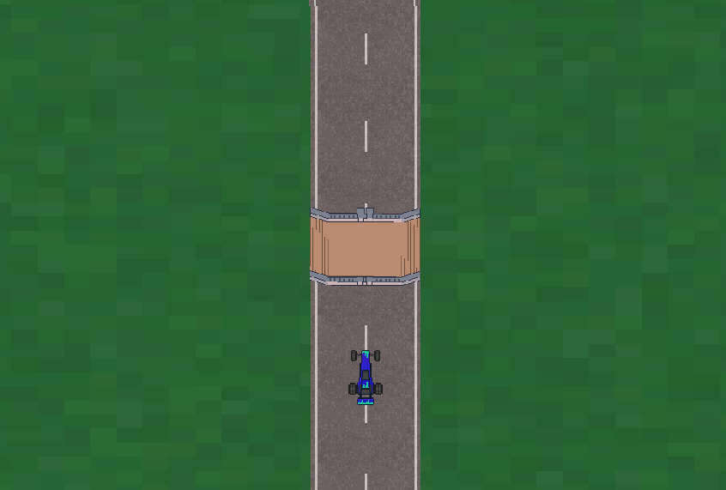

Figure 3: Bridge – a point of interest scattered along the track.

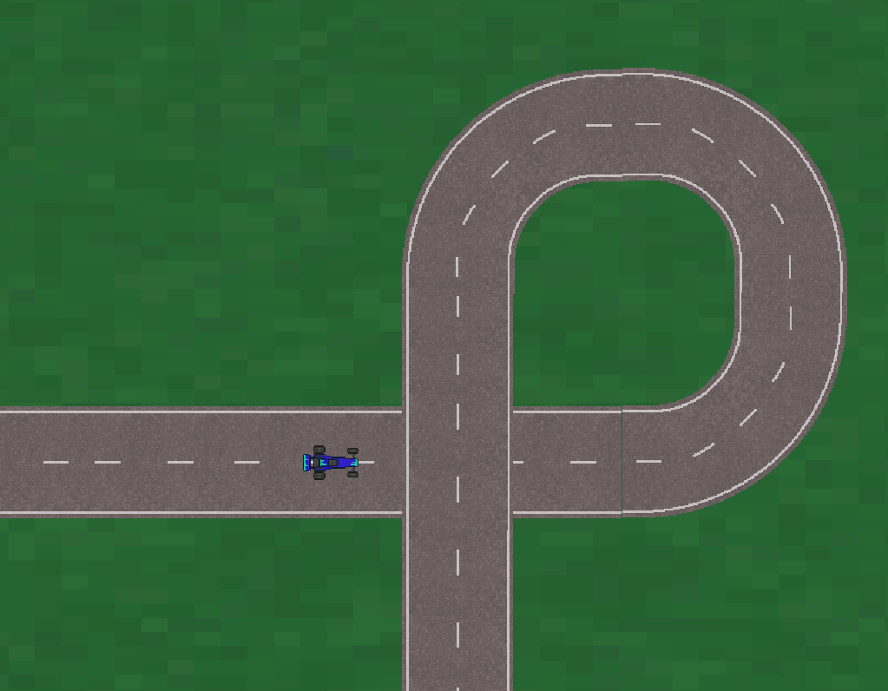

Figure 4: Intersect – a point of interest scattered along the track.

During the game, the system monitors various indicators, including times and landmarks on the track, the player's reaction time to the error, how he reacted to the error, i.e. how he continued to drive the vehicle after the error happened, all of which teach us about the accuracy of the corrective actions taken and observed patterns in the player's behavior (e.g., hesitation, repeated errors). These metrics provide insights into the player's attention processes and his ability to identify and correct errors. In addition, from these indicators, we can analyze the phenomenon of post-error slowing and understand the effects of ADHD on the phenomenon.

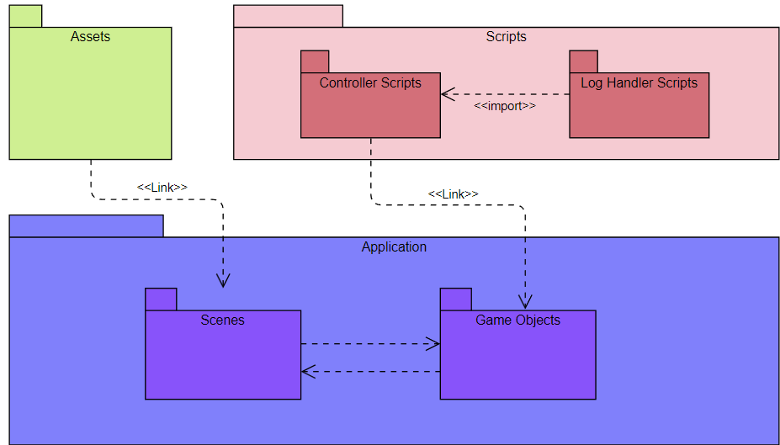

Figure 5: Package Diagram showing the structure of the models in our project.

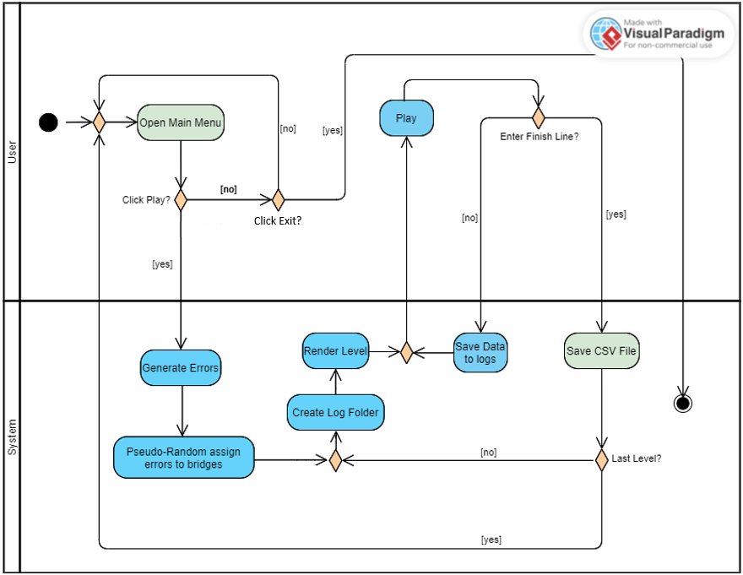

Figure 6: Activity Diagram showcasing the workflow of our project.

## **4.1 Log Files**

We generate and use three different log files to analyze the data collected. Two of the log files (*“DataLog_Map* and *“ErrorsSizes_Map*) are generated automatically by the system while the game is being played. The same data is then consolidated manually into a 3rd log file called *“Insights”* and analyzed (via a Python script) to conclude the player's behavior.

### **4.1.1 User Input Data Log**

This file is generated for every game level (a total of 5 per game session).

The data described in the file:

1. **Timestamp** of when the data was logged.
2. **X, and Y** coordinates of the car in the game screen.
3. **Velocity** vector in the x, and y axis directions and its magnitude.
4. **Acceleration** vector in the x, and y axis directions and its magnitude.
5. **Before_Err** is a flag used to mark when the user is about to enter a bridge that a controlled error will occur.
6. **After_Err** is a flag used to mark the data of the user after experiencing the controlled error.
7. **UP, DOWN, LEFT, and RIGHT** are flags indicating which arrow keys were pressed.

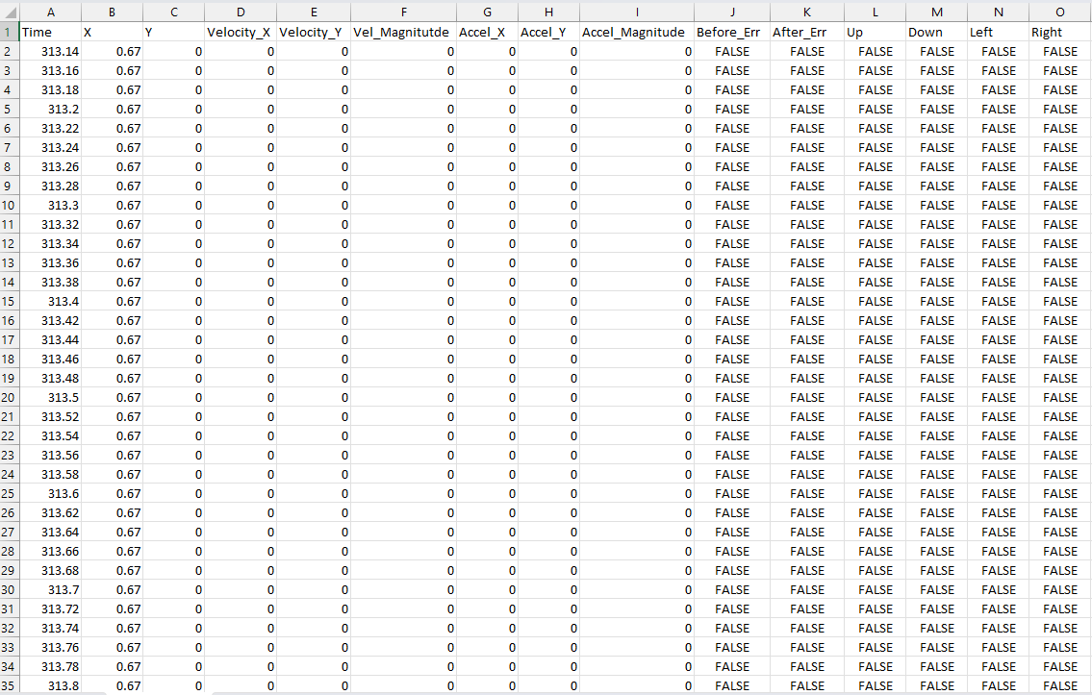

Figure 7: An example of a CSV output log file containing the input collected from the user.

### **4.1.2 Error Sizes Log**

This file is also generated for every game level.

The data described in the file:

1. **Err_Bridge** marks the point of interest in which the deviation error occurred.
2. **Err_Size** the magnitude of the deviation itself.
3. **Movement_Direction** indicates what was the direction of the deviation.

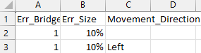

Figure 8: An example of a CSV output log containing the error location in the track, its size, and to what direction the error deviation was applied.

### **4.1.3 Insights Log**

We consolidate the collected data from each user log and then analyze it. We then manually insert it into an “Insights Log” log. This log file contains the results of the “raw” data. The data in this log:

1. **ADHD** flag indicating whether the test subject is diagnosed with ADHD.
2. **Err_Size** the magnitude of the deviation encountered.
3. **Correction** indicates whether the test subject corrected the deviation error using the arrow keys.
4. **Verbal_Detection** indicates whether the test subject verbally declared (while or after) encountering a deviation error.

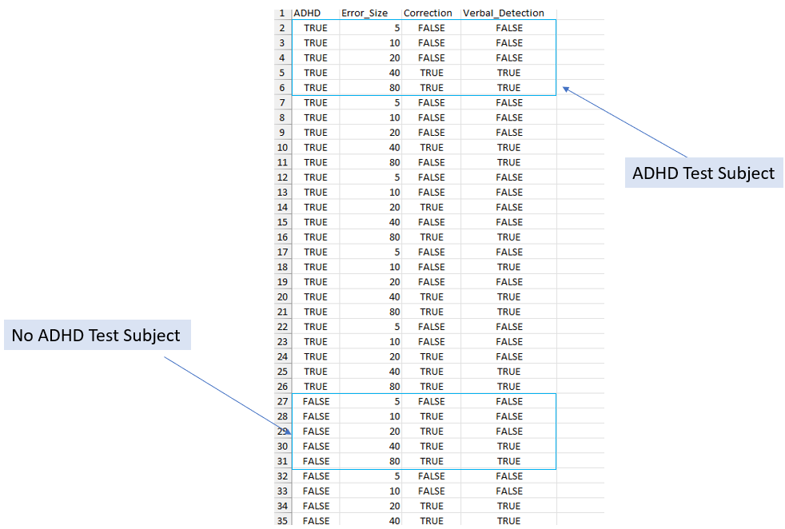

Figure 9: An example of a CSV “Insights” log showcasing the consolidated analysis results of various test subjects.

## **4.2 Artificial Errors**

Artificial errors are a key aspect of our system. We intentionally introduce errors to simulate real-world scenarios where mistakes may occur unexpectedly. This aspect of the system is designed to assess the user's ability to detect and correct errors. In each track, there are 5 bridges, and as the car passes underneath each bridge, it will momentarily be hidden from view [Fig 10]. During these obscured moments, controlled errors are introduced in the form of unexpected directional shifts [Fig 11], challenging the player to adapt quickly. The errors are designed to gauge the detection threshold of players, revealing how sensitive they are to changes in their environment. The occurrence of these errors is scattered pseudo-randomly among the bridges. This randomization adds an element of unpredictability that tests the player’s alertness, attention, and error detection.

We implemented 5 different error sizes:

**5%**- Barely noticeable***.*** These subtle errors test the lower limits of a player’s perception.

**10%** - Hardly noticeable. Slightly more perceptible, these errors challenge players to notice minor deviations.

**20%** - Somewhat noticeable. These are clearer shifts that most players might start to recognize.

**40%** - Very noticeable. At this level, the errors are evident, testing quick response and adaptation skills.

**80%** - Almost impossible to miss. These significant errors are meant to be easily detected by all players.

By analyzing the responses to each error, we can understand at what point errors become detectable to different individuals.



Figure 10: A presentation of the car being hidden from view when going under a bridge.



Figure 11: A presentation of deviation error. In this example, the size of the error is 40%

### **4.2.1 Artificial Error Generation**

To generate deviation errors in our simulation, we employ a ray tracing mechanism when the car enters a bridge or intersection.

Two ray trace vectors are cast from the center of the car to both its left and right sides, effectively measuring the available space in each direction [Fig 12]. We then calculate the magnitude of each vector:

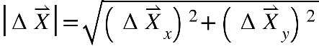

*Formula 1:* Magnitude of the vector.

to determine the potential deviation space on either side of the vehicle. The direction corresponding to the larger vector is chosen - this means that if the car has more room to deviate on one side, that side will be used to apply the error [Fig 13].

This method allows for controlled, context-sensitive errors that reflect the actual spatial conditions encountered by the car, thereby enhancing the unpredictability of the simulation. This approach also eliminates the risk of attempting to deviate the car in a direction where the spatial space available is too small. This ensures that the deviation is always detectable and aligns with the intended error magnitude, preventing scenarios where the error might be too subtle or might not occur at all.

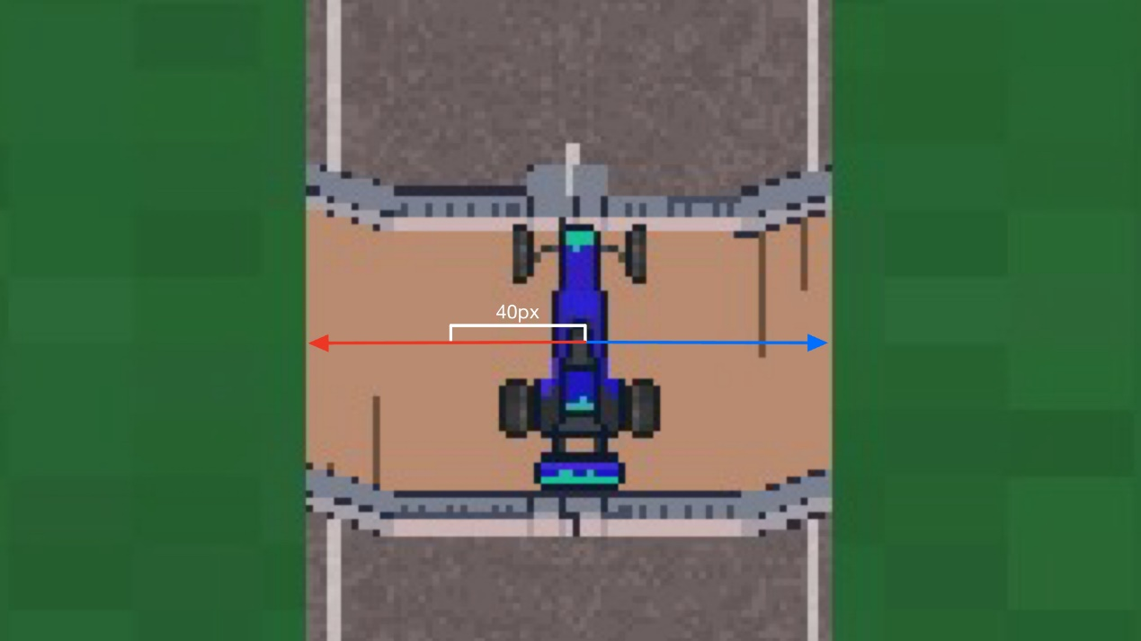

*Fig 12:* Example of two ray trace vectors (right direction – blue, left direction – red), assuming the length of the larger vector (red) is 100px then the 40% deviation will be a 40px shift in the left direction as shown as the white “distance” in px.

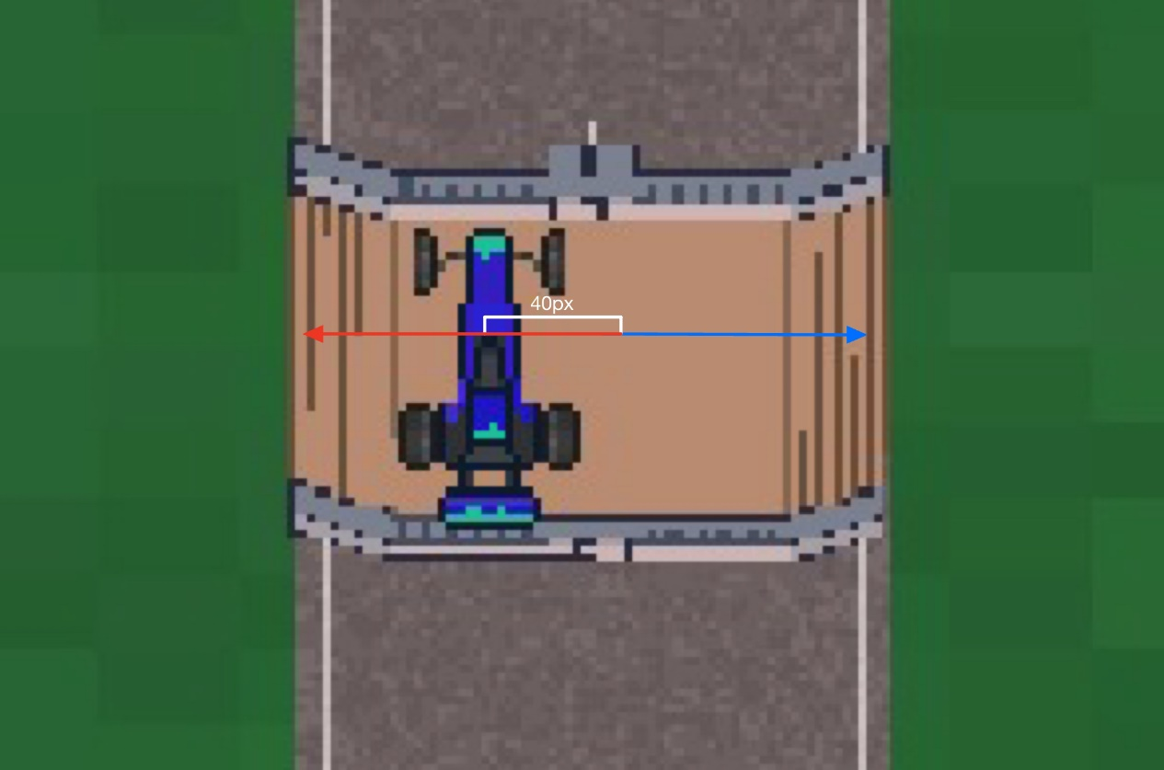

*Fig 13:* Example of the new position of the car underneath the bridge. We transformed the position of the car 40px to the left as calculated in Fig 10.

### **4.2.2 Artificial Error Response - Detection and Correction**

In our study, we defined a successful response to an error by the user using two primary criteria:

1. **Correction -** if a user successfully steers the car back to the center of the road within a predefined distance [Fig 14] after the deviation occurs, we consider the error detected. Corrections made outside of this designated distance are not recognized as valid error corrections. Such corrective actions are recorded in the *DataLog* CSV file as pairs of 'TRUE' values across two arrow keys, one from the top/bottom and one from the left/right arrow keys [Fig 15]. Pressing both keys simultaneously enables a precise steering adjustment [Fig 16], indicating that the car is returning to the intended trajectory.
2. **Verbal Detection -** after each gameplay round, we interview the test subject to gather feedback on their gameplay experience, and satisfaction with their performance. The main goal of the interview is to assess their awareness of any errors occurring during each round. If a user verbally identifies a deviation at a specific POI and this POI matches the location of the error logged in the *ErrorSizes* log, we consider it a successful detection. However, if the POI mentioned does not match the log, it is generally not considered a successful detection. An exception is made if the test subject incorrectly identifies the POI where the deviation occurred but has made a direct correction as per the first criterion. In such cases, we shall still consider it a successful error detection.

Both criteria allow us to assess both the intuitive and cognitive recognition of errors by users.

### **4.2.3 Post-Error Slowing Assessment**

To assess the post-error slowing phenomenon we calculated and compared the mean of the vehicle’s acceleration and velocity after each bridge per error size.

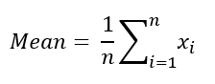

*Formula 2:* Mean equation, we denote Xi to be the velocity or acceleration of the vehicle when calculating each metric.

After calculating the means of each error size per bridge for each of the metrics, we proceed to calculate the relative change (in percentage). The percentage change is calculated between the error size mean value and the steady control (0% error) value.



*Formula 3:* Relative Percentage Change - used to calculate the relative change in the acceleration and velocity of the users after an error occurred and the “normal” acceleration/velocity exhibited when no errors occurred.

Due to the current implementation of our game task and system – the vehicle accelerates when an arrow key is pressed but there are no “gas or brake pedals” implemented. Thus, we were unable to assess the PES phenomenon accurately as the results received from our data were not indicative of real slowing in velocity or acceleration performed solely by the user itself but also changes in the metrics may have occurred due to the kinematic calculations performed “behind the scenes” by the Unity Engine itself. We do believe that this feature could be implemented in the future and will provide further results and insights regarding the PES phenomenon occurring in our system.

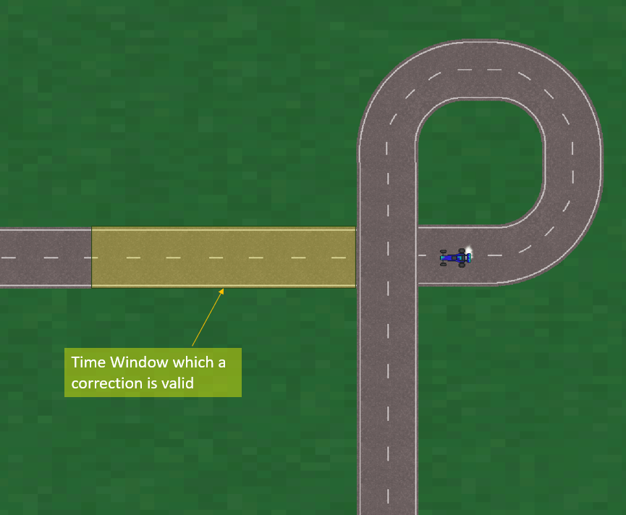

*Fig 14:* Example of a time window where we will log the correction is occurring. Whenever the car is within the yellow marked area, any corrections made are logged in the CSV file as valid.

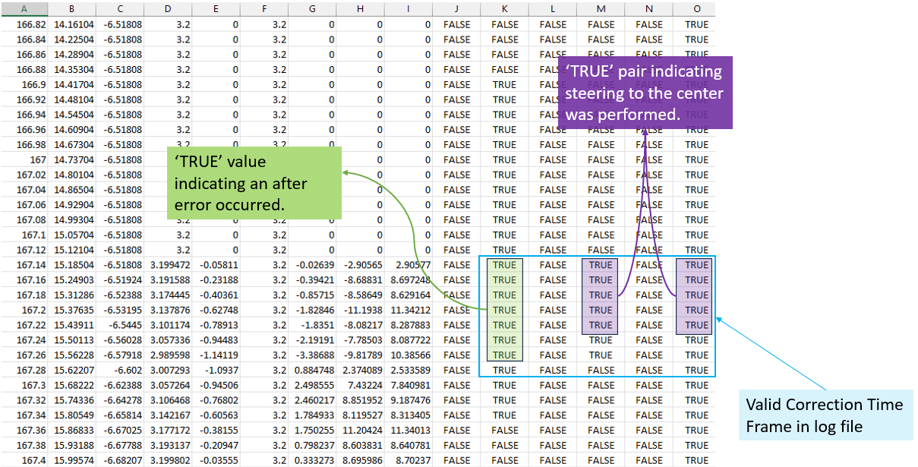

*Fig 15:* Example of a valid correction in the Data Log CSV file.



*Fig 16: Steering turns by pressing two arrow keys simultaneously.*

## **4.3 Kinematic Data**

While collecting the data, we calculate and extract different kinematic parameters from the user’s input. We save the data in a time frame of 0.02 seconds:

Let us denote the starting time, velocity, and position in the task as:

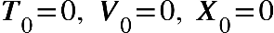

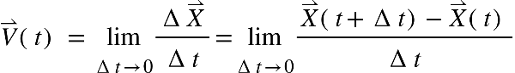

*Formula 3: Instantaneous Velocity of an object calculated as the derivative, of the position (displacement) with respect to time.*

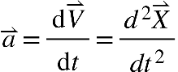

*Formula 4:* The acceleration *vector refers to the rate of change of the velocity of an object with respect to time.*

We also save the magnitude of each of the vectors as described in [Formula 1].

# 5. Results

The results of our research, as we have already mentioned in this article, are designed to help us answer the following questions:

1. Is there a threshold for error detection and correction in the context of our system? Does it differ between different individuals?
2. Does the threshold differ between people with and without ADHD?
3. Was the post-error slowing phenomenon exhibited after error occurrences?

To answer these questions, we divided the study between two testing groups consisting of 8 participants - a group of subjects who do not suffer from ADHD and a group of subjects diagnosed with ADHD. Each group of participants performed the game task, and we analyzed the results of the data collected as we defined in [paragraph 4.2.2].

We instructed the participants to steer the vehicle on the track and try to keep the vehicle in the middle of the track as much as possible. Our basic premise was that the vehicle enters a bridge when it is very close to the middle of the track and therefore after an error in which it deviates from the middle in a certain direction, the participant will correct it by pressing two arrow keys simultaneously [Fig 16] steering the car back to the intended trajectory.

After each round, we asked the participants what their experience was so far with the game. We don’t explicitly state or ask about error occurrences, nor do we recognize the existence of such errors to not create an expectation of an error in the following rounds. Still, some subjects recognized a change in the vehicle's position, meaning they detected the error.

**1. Is there a varying threshold of error detection and correction?**

As mentioned, we tested different sizes of deviation errors [paragraph 4.2] by changing the vehicle’s position to test the threshold for detecting and correcting the errors.

Let us examine the results of the analysis of the data collected [paragraph 4.2.2] from the NO ADHD i.e. the control group.

The chart in [Fig 16] refers to all participants in the group.

1. **X-Axis** - indicates the size of the error in percentages.
2. **Y-Axis** - indicates the number of different participants who corrected, detected, or both for each of the errors.

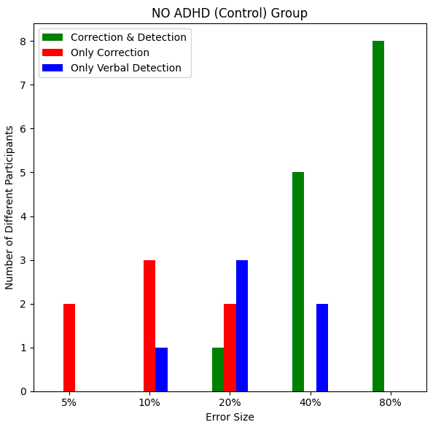

*Fig 16:* The chart depicts the number of participants who detected, corrected, or both out of the entire group. The x-axis refers to the error size, and the y-axis refers to the number of different participants.

For the **5%** error size, two participants responded to the error by correcting it.

For the **10%** error size, 4 out of 8 participants responded to the error. Three of them corrected the error by steering the vehicle back to the middle of the track after the deviation, while two only detected the error.

For the **20%** error size, 6 out of 8 participants responded to the error. Three only detected the error, two only corrected it, and one detected and corrected it.

For the **40%** error size, 7 out of 8 participants responded to the error. Five detected and corrected it, and two detected it.

For the **80%** error size, all participants responded to the error, and log analysis confirmed that they also corrected it.

The detection and correction patterns of the control group (i.e. “healthy” people) exhibit consistent activity in detecting and correcting errors (i.e. responding to the errors) across all error sizes.

These results may indeed reflect the fact that there is a threshold for detecting and correcting errors.

**2. Does the threshold differ between people with and without ADHD?**

To answer this question, we will examine the results of the participants who are diagnosed with ADHD and compare them to the results we presented previously.

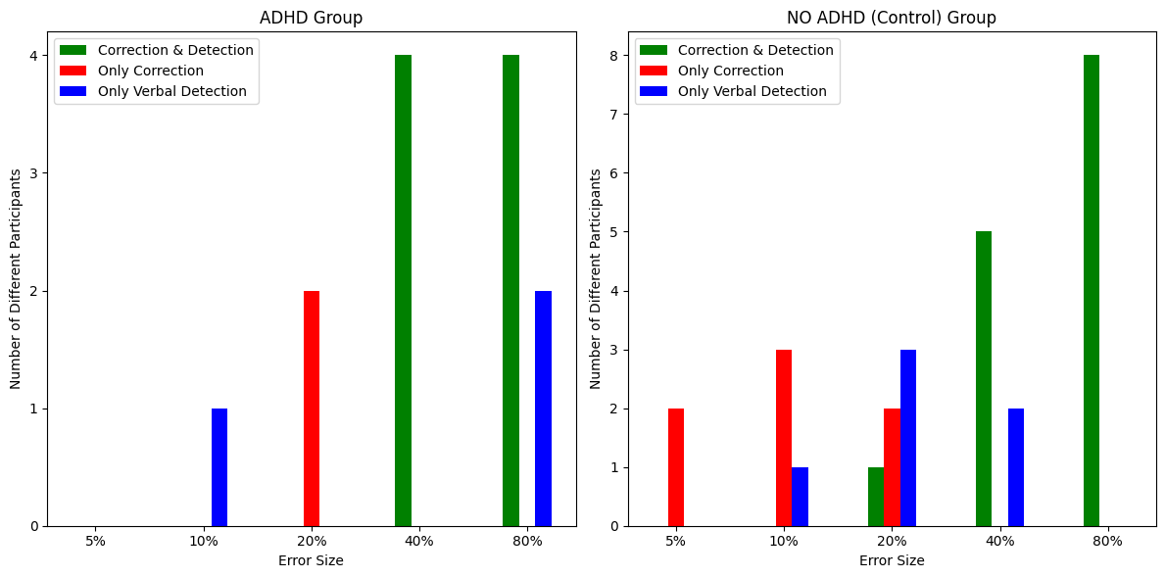

Fig 17: Comparison of the error detection and correction results from each testing group. Each group has 8 participants.

For the **5%** error size:

* In the control group 2 out of 8 participants responded to the error.
* In the ADHD group, none of the participants responded to the error.

For the **10%** error size:

* In the control group, 4 out of 8 participants responded to the error.
* In the ADHD group, only one participant detected the error but did not correct it.

For the **20%** error size**:**

* In the control group, 6 out of 8 participants responded to the error.
* In the ADHD 2 out of 8 participants responded to the error by correcting it. None of the participants detected it.

For the **40%** error size**:**

* In the control group, 7 out of 8 participants responded to the error.
* In the ADHD 4 out of 8 participants responded to the error by correcting and detecting it.

For the **80%** error size**:**

* In the control group, all the participants responded to the error.
* In the ADHD 6 out of 8 participants responded to the error by correcting and detecting it, while two participants only detected it.

We can observe that the control group had better error detection and correction results in each error size compared to the ADHD group.

We shall conduct a more comprehensive analysis. In this analysis, both the detection and correction values of each participant (calculated from the “Insights” log) are combined into a single measure of response to the error.

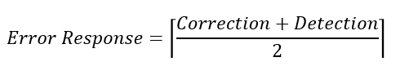

*Formula 5:* Error Response calculated from the Insights.CSV log file for each of the participants*.*

For e.g., a participant that has a True value in both correction and detection or a True value in only one of the columns will have an Error Response = 1, else 0.

This approach will allow us to analyze and compare the differences in the thresholds between the groups and allows us to analyze the results in a more general way while ignoring the type of action that the participant performed but whether there was any response to the error presented or not.

We can see in [Fig 18] that the control group consistently exhibits better response rates to errors. This group seems to have a more balanced attention to detail, possibly indicating better error-monitoring capabilities. On the other hand, the ADHD group mainly responded to larger errors. This might reflect a lesser ability to detect smaller errors or inaccuracies. This may also reflect a lower attention to detail.

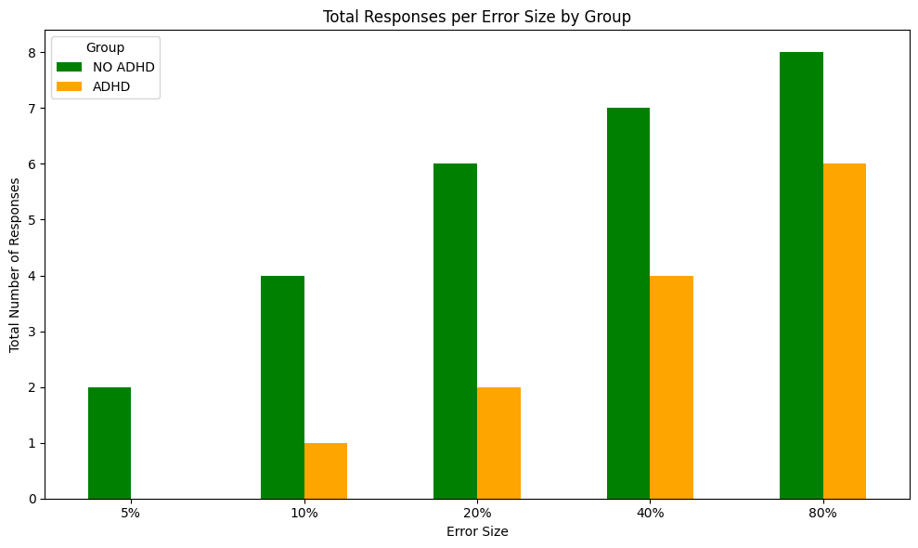

Fig 18: Error Response comparison between the testing groups. Y-axis values refer to the number of different participants in each group, and the X-axis values are the error detection, and correction values combined into a single metric.

1. **Was the post-error slowing phenomenon exhibited after error occurrences?**

As we explained in [paragraph 4.2.3] we were unable to accurately assess and determine if post-error slowing was exhibited by the participants after an error. We believe that such a feature can be implemented in the future and will allow us to examine post-error slowing more accurately.

Furthermore, we could integrate EEG signal analysis to expand the use and utility of our system. Participants could be equipped with electrodes to log brain signals while engaging in the task. This setup would enable us to analyze the neurological responses associated with error detection or inaccuracies. By examining EEG data, we could identify common neural signatures that have been researched and are known to occur when humans encounter errors. This integration would not only enrich our understanding of cognitive responses but also refine our ability to assess and interpret error-related changes in brain activity.

# 

# 6. Conclusions

The study included 3 main questions mentioned in the previous section.  
After analyzing the results of the study we were able to answer 2 of the questions.

We were able to show that a threshold for identifying and correcting errors exists in the context of our system and research environment. We were able to conclude that said threshold does indeed vary between people diagnosed with ADHD and those who are not.

The control group exhibited greater attention to detail and a consistent response error rate, indicating a lower threshold for error detection and correction (smaller errors are more noticeable), possibly indicating better error-monitoring capabilities. On the other hand, the ADHD group mainly responded to larger errors, indicating a higher threshold. This might reflect a lesser ability to detect smaller errors or inaccuracies and may be indicative of lower attention to detail.

Unfortunately, we could not reach a result that would answer the third question - the phenomenon of slowing down after an error. Still, we created a tool that can be improved in the future to answer this question.

In addition, following the results of the research, the tool we developed could in the future be used as an aid in the diagnosis of ADHD and also possibly to perform an EEG wave reading while using the tool we developed to expand the research regarding brain activity during exposure to errors.

# 

# REFERENCES

[1] *[Notebaert, W., Houtman, F., Van Opstal, F., Gevers, W., Fias, W., & Verguts, T. (2009). Post-error slowing: an orienting account. Cognition, 111(2), 275-279.‏](https://www.sciencedirect.com/science/article/pii/S0010027709000419)*

[2] [*Botvinick, M. M., Braver, T. S., Barch, D. M., Carter, C. S., & Cohen, J. D. (2001). Conflict monitoring and cognitive control. Psychological review, 108(3), 624.‏*](https://psycnet.apa.org/record/2001-07628-005)

[3] [*MacLeod, C. M. (2005). The Stroop Task in Cognitive Research.‏*](https://psycnet.apa.org/record/2004-19025-002)

[4] [*Verbruggen, F., Notebaert, W., Liefooghe, B., & Vandierendonck, A. (2006). Stimulus-and response-conflict-induced cognitive control in the flanker task. Psychonomic Bulletin & Review, 13, 328-333.‏*](https://link.springer.com/article/10.3758/BF03193852)

[5] [*Danielmeier, C., Eichele, T., Forstmann, B. U., Tittgemeyer, M., & Ullsperger, M. (2011). Posterior medial frontal cortex activity predicts post-error adaptations in task-related visual and motor areas. Journal of Neuroscience, 31(5), 1780-1789.*](https://www.jneurosci.org/content/31/5/1780.full)

[6] [*Christensen, K. E., & Lundwall, R. A. (2018). Errors on a computer task and subclinical symptoms of attention‐deficit/hyperactivity disorder (ADHD). Scandinavian journal of psychology, 59(5), 511-517.‏*](https://onlinelibrary.wiley.com/doi/abs/10.1111/sjop.12462)

[7] *[Schachar, R. J., Chen, S., Logan, G. D., Ornstein, T. J., Crosbie, J., Ickowicz, A., & Pakulak, A. (2004). Evidence for an error monitoring deficit in attention deficit hyperactivity disorder. Journal of abnormal child psychology, 32, 285-293.‏](https://link.springer.com/article/10.1023/B:JACP.0000026142.11217.f2)*

[8] [*Botvinick, M. M., Cohen, J. D., & Carter, C. S. (2004). Conflict monitoring and anterior cingulate cortex: an update. Trends in cognitive sciences, 8(12), 539-546.‏‏*](https://www.sciencedirect.com/science/article/pii/S1364661304002657)

[9] [*https://www.mayoclinic.org/tests-procedures/eeg/about/pac-20393875*](https://www.mayoclinic.org/tests-procedures/eeg/about/pac-20393875)

[10] [*Dörner, D., & Schaub, H. (1994). Errors in planning and decision‐making and the nature of human information processing.*Applied psychology*,*43*(4), 433-453.‏*](https://iaap-journals.onlinelibrary.wiley.com/doi/abs/10.1111/j.1464-0597.1994.tb00839.x)

[11] [*Falkenstein, M., Hoormann, J., Christ, S., & Hohnsbein, J. (2000). ERP components on reaction errors and their functional significance: a tutorial. Biological psychology, 51(2-3), 87-107.‏*](https://www.sciencedirect.com/science/article/pii/S0301051199000319)

[12] [*American Psychiatric Association. (2015).*Neurodevelopmental disorders: DSM-5® selections*. American Psychiatric Pub.‏*](https://books.google.co.il/books?hl=iw&lr=&id=yoYJDAAAQBAJ&oi=fnd&pg=PP1&dq=American+Psychiatric+Association,+Neurodevelopmental+disorders&ots=S5HKO8FheV&sig=INp2pC_PvsKTJyxdl1GDCceD7HI&redir_esc=y#v=onepage&q=American%20Psychiatric%20Association%2C%20Neurodevelopmental%20disorders&f=false)

[13] *[An, K. N. (1984). Kinematic analysis of human movement.](https://link.springer.com/article/10.1007/BF02371451)*[Annals of biomedical engineering](https://link.springer.com/article/10.1007/BF02371451)*[,](https://link.springer.com/article/10.1007/BF02371451)*[12](https://link.springer.com/article/10.1007/BF02371451)*[, 585-597.‏.‏](https://link.springer.com/article/10.1007/BF02371451)*

[14] [*de los Reyes-Guzmán, A., Dimbwadyo-Terrer, I., Trincado-Alonso, F., Monasterio-Huelin, F., Torricelli, D., & Gil-Agudo, A. (2014). Quantitative assessment based on kinematic measures of functional impairments during upper extremity movements: A review.*Clinical Biomechanics*,*29*(7), 719-727.‏*](https://www.sciencedirect.com/science/article/pii/S0268003314001454)

[15] [*Dahan, A., & Reiner, M. (2017). Evidence for deficient motor planning in ADHD.*Scientific reports*,*7*(1), 1-10.‏*](https://www.nature.com/articles/s41598-017-09984-7)